**DATABASE LAB PROJECT**

GROUP MEMBERS:

**MUHAMMAD UMAID KHAN KHAKWANI**

I19-0666

**GHULAM MUSTAFA**

I19-0677

**IQRA MANZOOR**

I19-0614

SECTION D

FITME

* ERD:

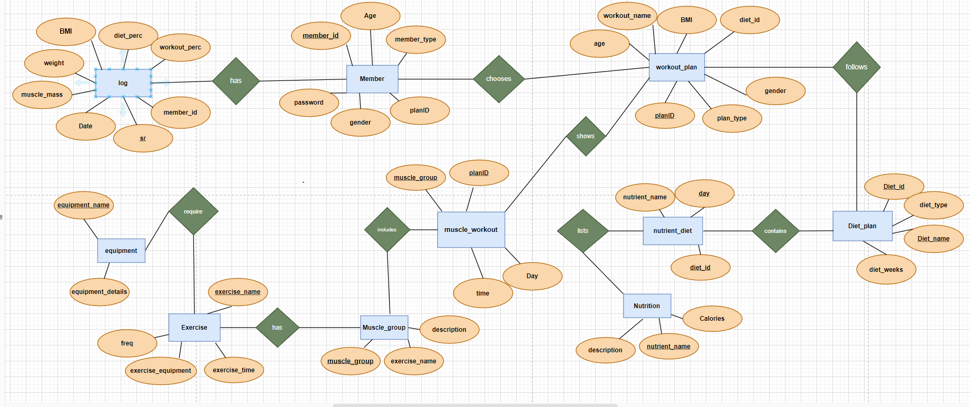

* Table description:
* Member:

Primary key is member_id. It is set to autogenerate the distinct values after every insertion. This table will be used to collect the information about the members and assign them a unique id which is set as primary key.

* Member_id (primary key)
* Password
* planID
* member_type
* Age
* Gender
* Workout_plan:

Primary key is planID. It is set to autogenerate the distinct values after every insertion. this table is used to make a plan for the workout.

* planID (primary key)
* workout_name
* Diet_id (foreign key )
* Age
* Gender
* Plan_type
* BMI
* Muscle_workout:

PlanID and muscle-group are composite primary keys of this table. This table contains the information of which muscle group the user targeted.

* planID (composite primary key)
* muscle_group (composite primary key)
* Day
* Time
* Muscle_group:

Muscle_group is the primary key in this table. This table contains the description and the exercise name of the targeted muscle group.

* Muscle_group (primary key)
* Description
* Exercise_name
* Exercise:

Exercise_name is the primary key in this table. This table stores the descriptions of the exercises to be performed.

* Exercise_name (primary key)
* Freq
* Exercise_equipment
* Exercise_time
* Equipment:

Equipment_name is the primary key in this table. This table stores the descriptions of the equipment on which the exercise is to be performed.

* Equipment_name (primary key)
* Equipment_details
* log:

Sr is the primary key in this table. It is set to autogenerate the distinct values after every insertion. This table maintains the log of each member

* SR (primary key)
* Member_id (foreign key)
* Workout_perc
* Diet_perc
* BMI
* Weight
* Muscle_mass
* Date
* Diet_plan:

Diet_id is the primary key in this table. This table stores the descriptions of the diet plans predefined.

* diet_id (primary key)
* diet_name
* diet_weeks
* diet_type
* nutrient_Diet:

Diet_id and day are composite primary keys in this table. This table stores the descriptions of the day number, the diet has to be followed.

* diet_id (composite primary key)
* day (primary key)
* nutrient_name (foreign key)
* Nutrition:

Nutrient_name is the primary key in this table. This table stores the description of the calories and meals of the day.

* Nutrient_name (primary key)
* Calories
* Description
* Schema diagram

s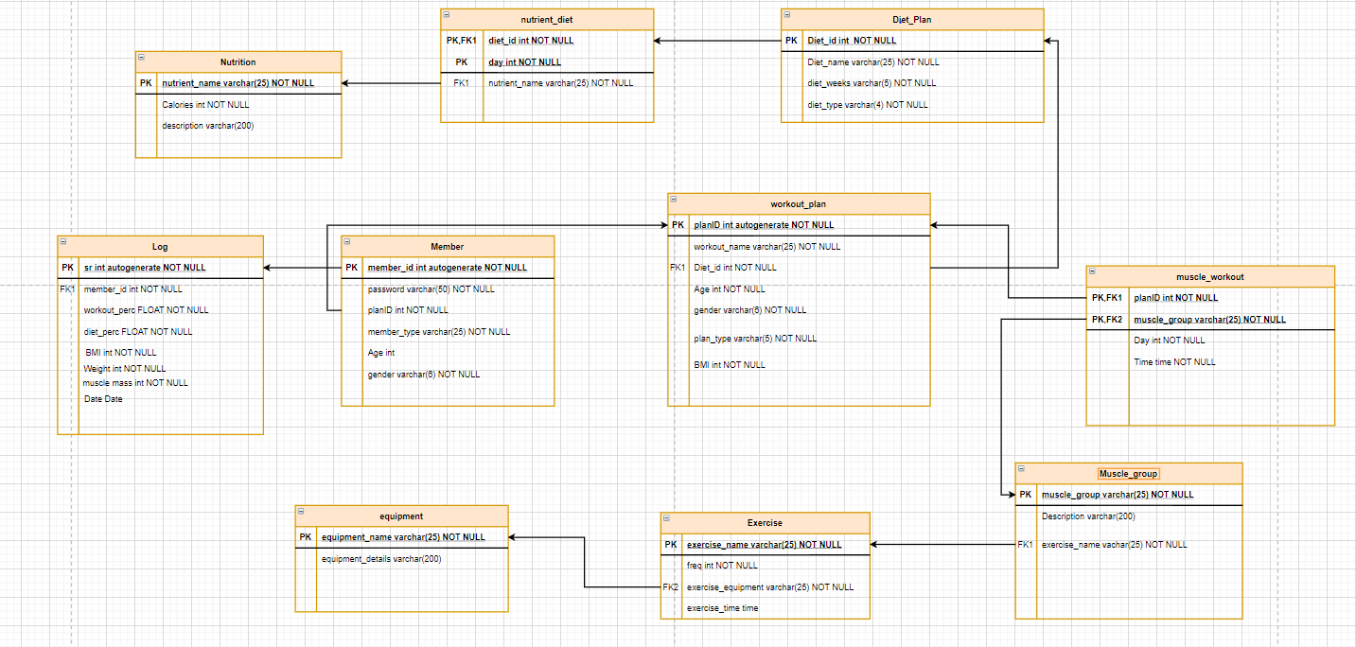

* interface
* **login**

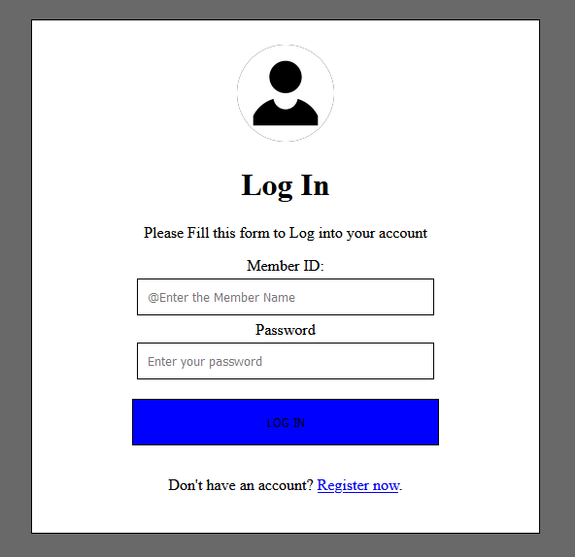

* **Log**

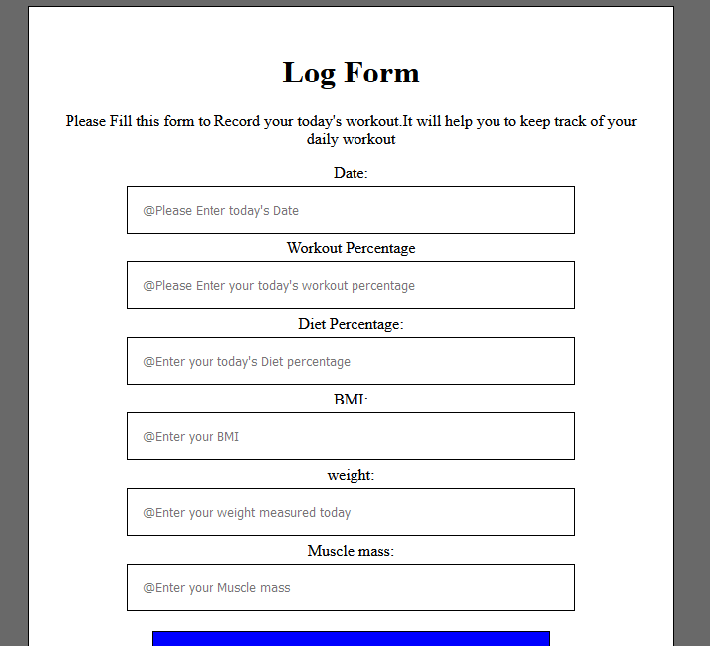

* **Front page**



* **Personalize**

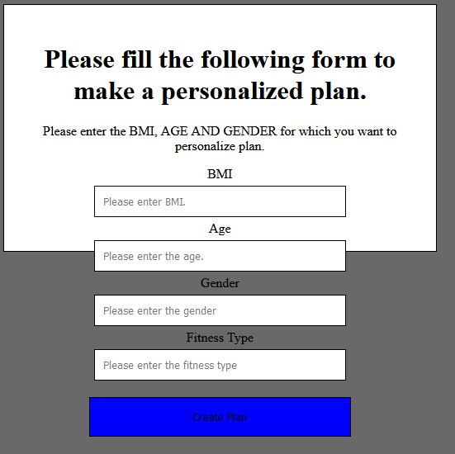

* **Register**

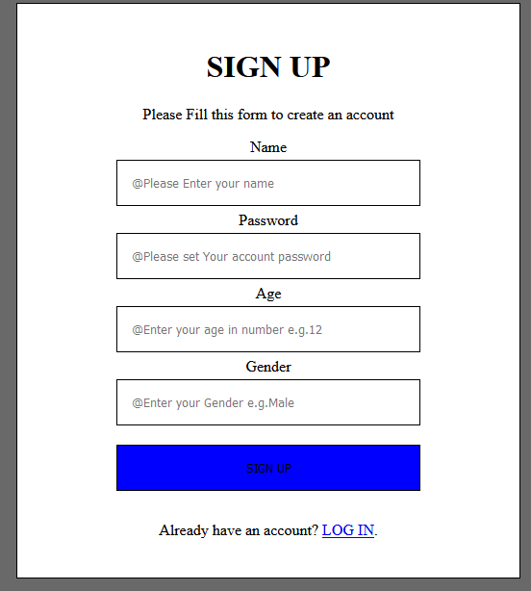

* **Exercise_type**

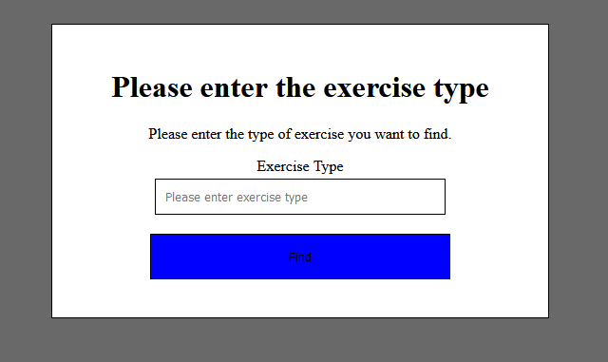

* **Diet_plan**

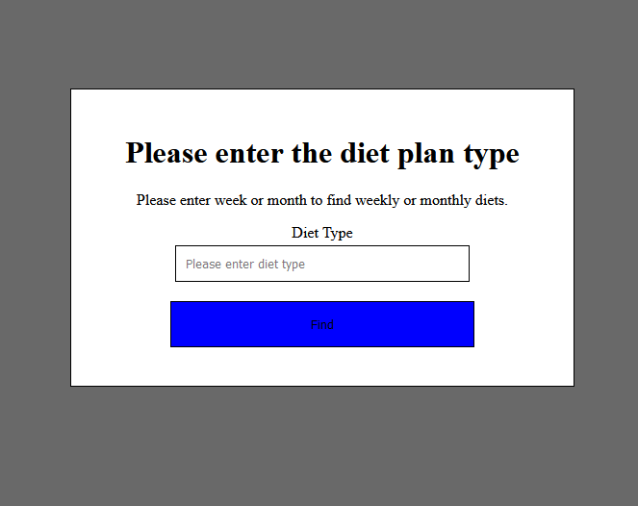

* **Create workout**

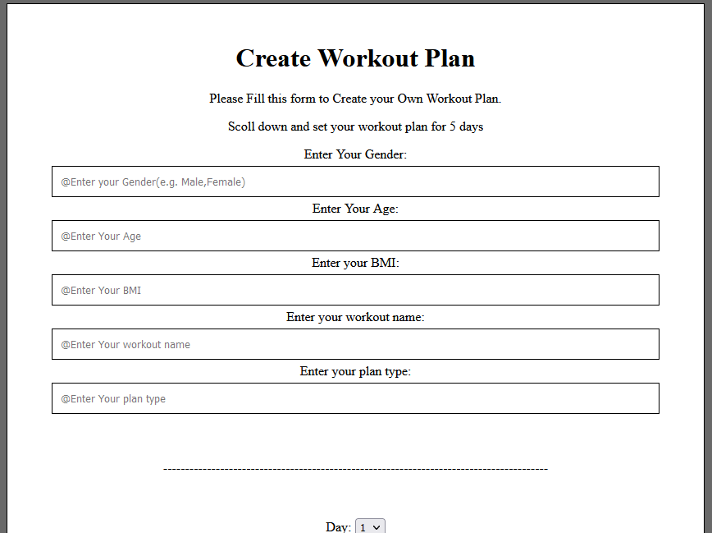

* tables description:
* Nutrition

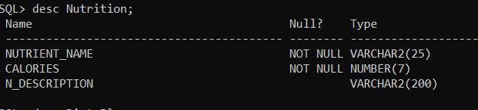

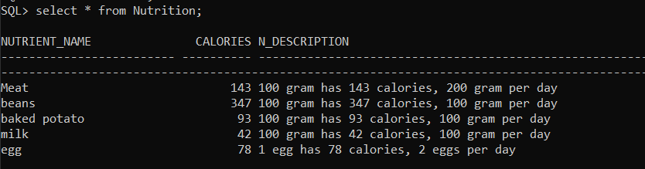

* Diet_plan

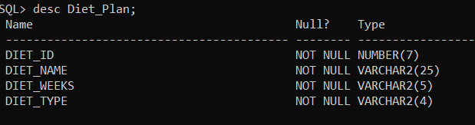

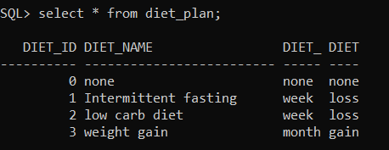

* Equipment

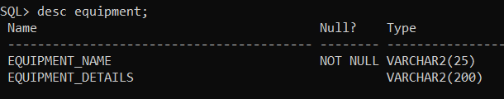

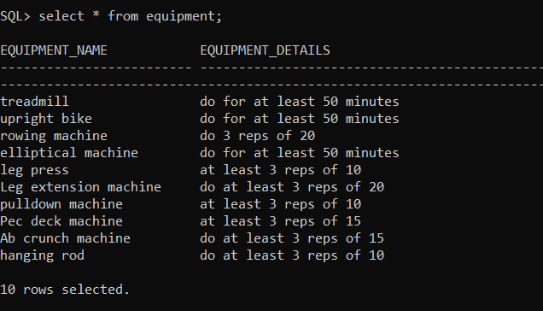

* Exercise

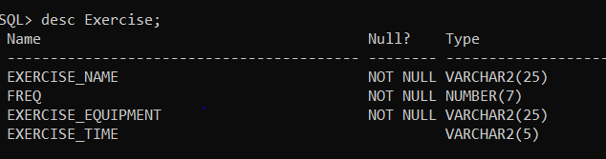

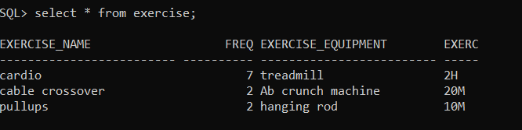

* Muscle_group

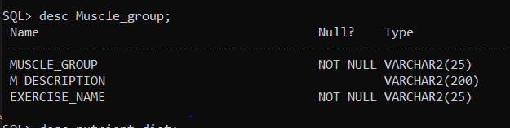

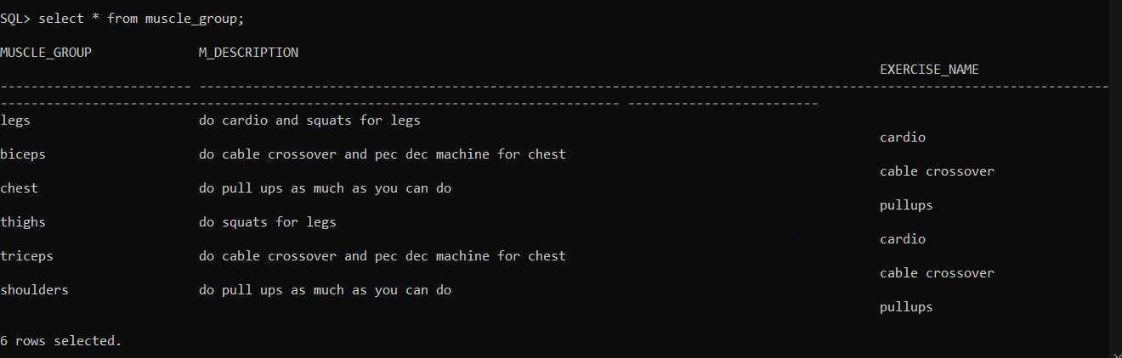

* Nutrient_diet

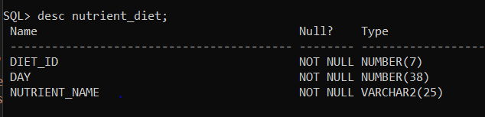

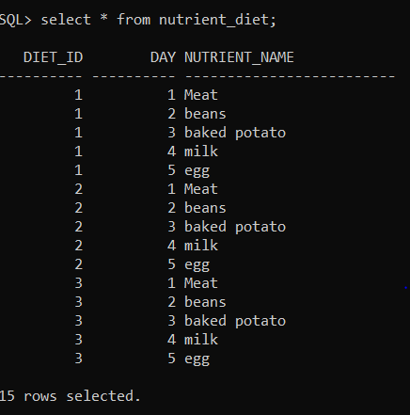

* Workout_plan

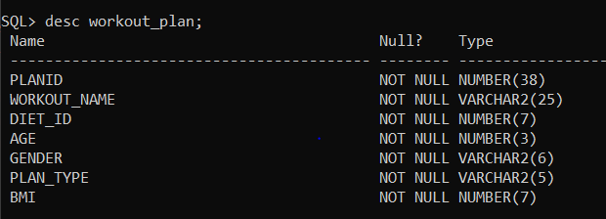

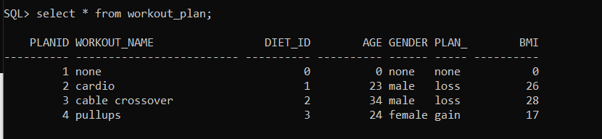

* Muscle_workout

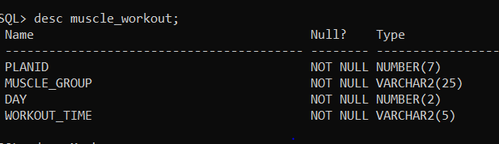

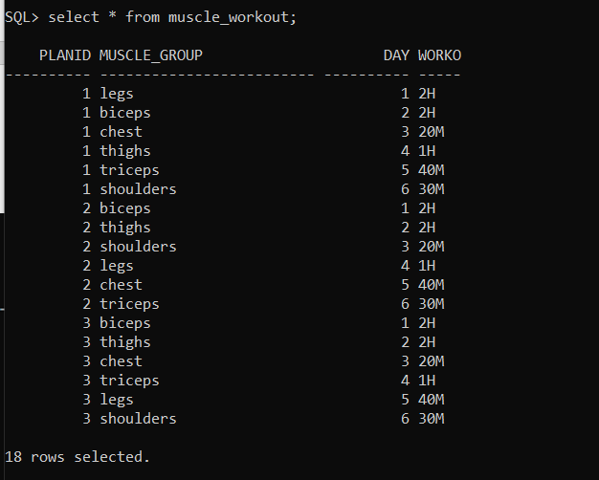

* Member

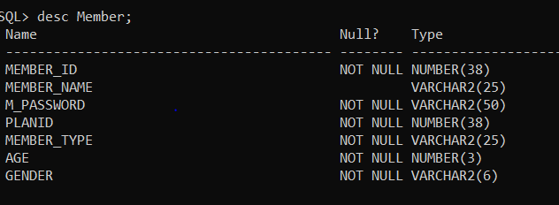

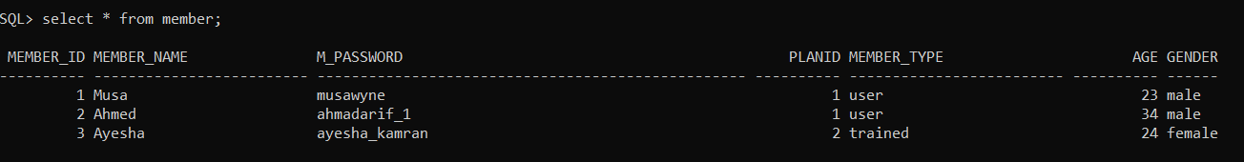

* Log

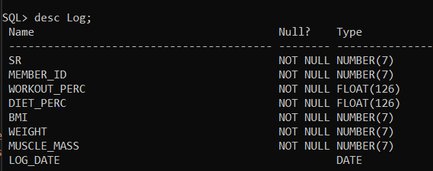

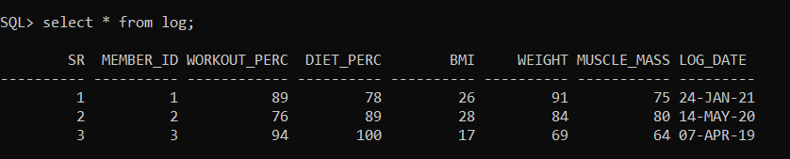

* PHP QUERIES description:
* Login:
  + - select * from Member where member_name = '".$_POST["user"]."' and M_password = '".$_POST["password"]."'";

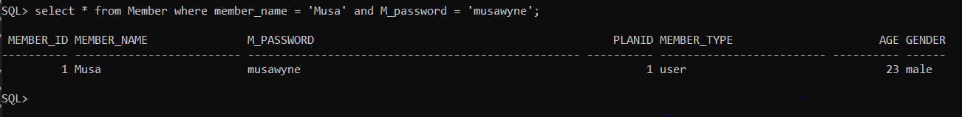

**Detail:**

The above-mentioned query is used to search from the entered data, if the data is found then it goes to the front page but if the data is not the user is redirected to the login page.

* Register:
  + - insert into Member(member_name,M_password,planID,member_type,Age,gender) VALUES ('".$_POST["Member_name"]."','".$_POST["M_password"]."', 1, 'none',".$_POST["Age"].", '".$_POST["Gender"]."')";

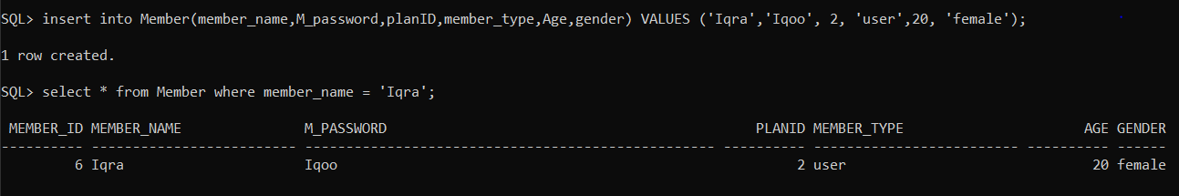

**Detail:**

The above-mentioned query is used to insert the new member in the database.

* Diet PLan Report:
  + - select * from Diet_Plan dp join nutrient_diet nd on (dp.diet_id = nd.diet_id) where dp.diet_weeks = '".$_POST["type"]."'";

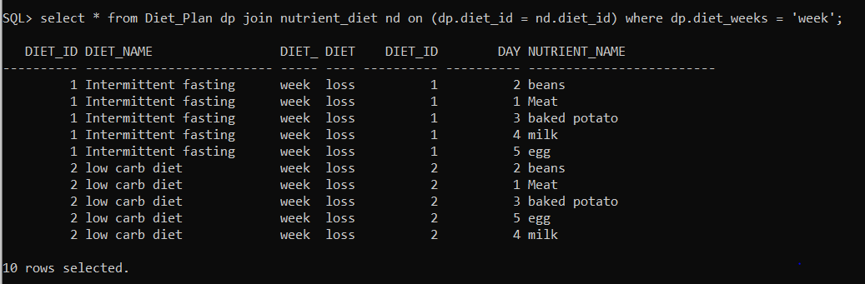

**Detail**:

The above-mentioned query is used to show all the diet plan details where diet period is set for “week”.

* Exercise Type Report:
  + - select distinct e.exercise_name, e.freq, e.exercise_equipment, e.exercise_time from muscle_workout mw join workout_plan wp on (mw.planID = wp.planID) join muscle_group mg on (mg.muscle_group = mw.muscle_group) join exercise e on (e.exercise_name = mg.exercise_name) where wp.plan_type = '".$_POST['type']."'";

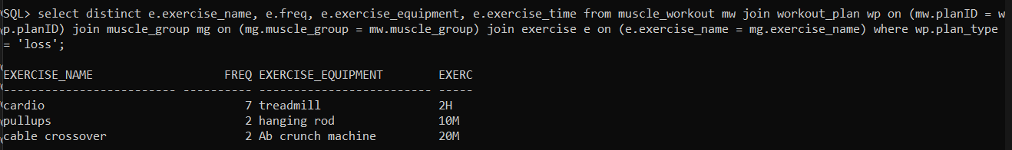

**Detail**:

The above-mentioned query is used to show all exercises and exercise equipment required for weight type “loss”.

* Search Query for Diet:
  + - select * from diet_plan where diet_name like '%".$_POST['box']."%';

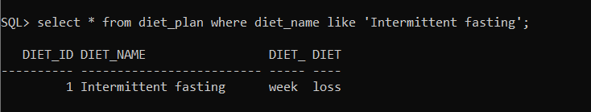

**Detail**:

The above-mentioned query is used to show all diet plans which contains the diet name “intermittent fasting”.

* Search Query for Exercise:
  + - select * from exercise where exercise_name like '%".$_POST['box']."%';

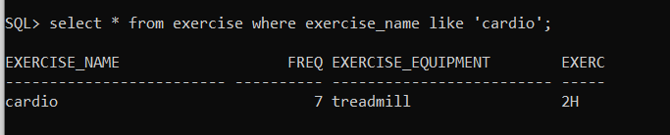

**Detail**:

The above-mentioned query is used to show all exercise details whose exercise name is “cardio”.

* LOG:
  + - insert into Log(member_id, workout_perc, diet_perc, BMI, Weight, muscle_mass, Log_Date) VALUES (".$row['MEMBER_ID'].",".$_POST["workout_perc"].",".$_POST["diet_perc"].",".$_POST["BMI"].",".$_POST["weight"].",".$_POST["muscle_mass"].", TO_DATE('".$_POST["w_Date"]."', 'DD-MON-YYYY'))

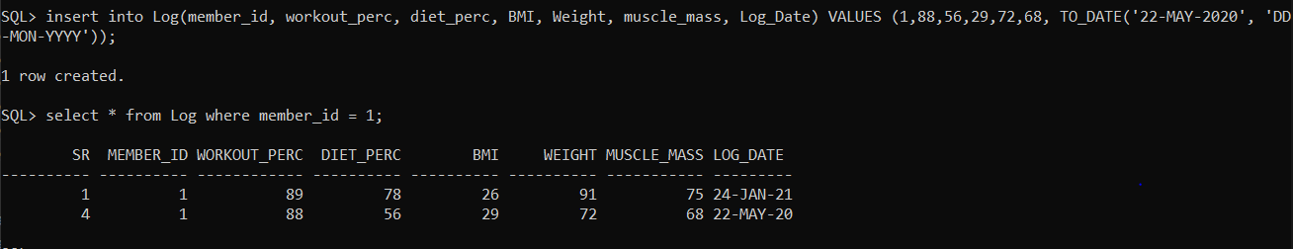

**Detail**:

The above-mentioned query is used to insert a new log of the same member_id/member.

* Create your personalize plan:
  + - select * from workout_plan where (age > ".$_POST['age']." - 5 AND age < ".$_POST['age']." + 5) AND (gender = '".$_POST['gender']."') AND (plan_type like '%".$_POST['type']."%') AND (BMI > ".$_POST['bmi']." - 5 and BMI < ".$_POST['bmi']." + 5)

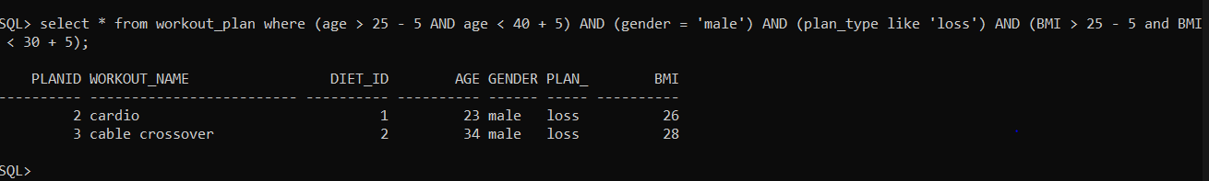

**Detail**:

The above-mentioned query is used to show all the workout_plans which condition specifying age between 20 to 45, gender should be male, plan should be weight loss and the BMI should be in between 20 to 35.

* Personalize plan data for personalize plan exercises:
  + - "select * from muscle_workout where planID = '".$row['PLANID']."'"

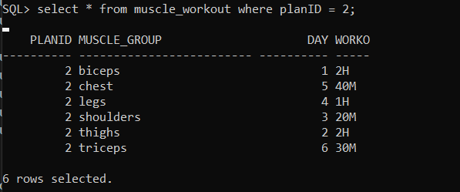

**Detail**:

The above-mentioned query is used to show all the muscle workouts whose planID is 2.